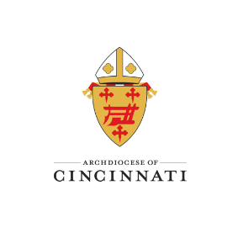

2024 Wedding Anniversary Certificate and Golden Jubilee Anniversary Masses
Bulletin Insert for Parishes – To be posted until June 9, 2024
Are you celebrating a significant wedding anniversary in 2024?
25, 30, 35, 40, 45, 50, 55, 60, 65, 70, or 75 years…
Request a certificate signed by Archbishop Dennis M. Schnurr by visiting our web page here: https://www.centerforthenewevangelization.org/marriage-family/resources/wedding-anniversary-certificate-request
Please note anniversary certificates will be mailed to you once a month from January 2024 through March 2024. For requests from March 1, 2024 through June 15, 2024, anniversary certificates will be mailed to your parish in late June. If you have any questions, please contact the Marriage and Family Evangelization office at cne@catholicaoc.org.
+ + + + + + + +
Are you celebrating your 50th Wedding Anniversary in 2024?
Married couples celebrating their 50th Wedding Anniversary in 2024 are invited to attend one of the following Golden Anniversary Masses:
- Saturday, September 7 at 4:00 p.m. at St. John the Baptist, Tipp City
  - Celebrant: TBD
- Sunday, September 8 at 11:00 a.m. at the Cathedral Basilica of St. Peter in Chains, Cincinnati
  - Celebrant: Archbishop Dennis M. Schnurr
Registration is required to attend one of the Golden Jubilee Wedding Anniversary Masses. Please register online by completing the anniversary certificate request form linked here: https://www.centerforthenewevangelization.org/marriage-family/resources/wedding-anniversary-certificate-request
If you have any questions about the Golden Jubilee Anniversary Mass, please contact the Marriage & Family Evangelization Office at cne@catholicaoc.org

