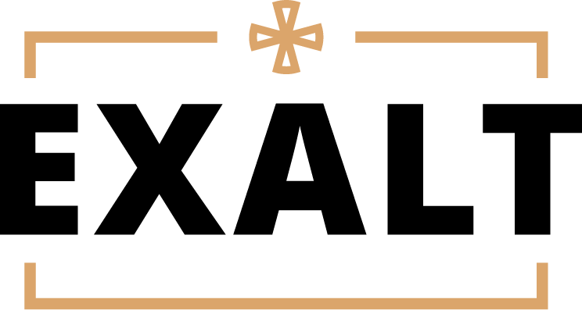

ARCHDIOCESE OF CINCINNATI
PERMISSION, RELEASE, AND AUTHORIZATION TO SEEK MEDICAL TREATMENT FORM (rev. 7-9-2020)

- I, the custodial parent/legal guardian of (the “Child”), give permission for my Child to participate in the activity described on the Activity Information Form (the “Activity”) and release from all liability, indemnify, and hold harmless _______________________________(print name of parish and school) (“Parish and School”), the Archdiocese of Cincinnati (the “Archdiocese”), the Archbishop of Cincinnati (the “Archbishop”), both individually and as trustee for the Archdiocese, all parishes and schools within the Archdiocese, and all of their agents, representatives, volunteers, and employees from any and all liability, claims, judgments, damages, costs and expenses, including attorneys’ fees, arising out of any injury, illness, infectious and/or communicable disease (such as MRSA, influenza, or COVID-19), or death, (including any injury, illness, infectious and/or communicable disease, or death caused by the negligence of Parish and School, the Archbishop, the Archdiocese, any parish or school within the Archdiocese, or any of their agents, representatives, volunteers, or employees) incurred by my Child while participating in the Activity, traveling to or from the Activity, or while using the facilities and equipment of the Parish and School. I further agree not to bring or prosecute or allow to be brought or prosecuted (including, but not limited to, prosecution through subrogation) in my name, or on behalf of my Child, any claims, lawsuits, or actions against Parish and School, the Archbishop, the Archdiocese, all parishes and schools within the Archdiocese, or their agents, representatives, volunteers, and employees.

- I understand that my Child’s participation in the Activity is purely voluntary and is a privilege and not a right, and that my Child, and I on behalf of my Child, agree to my Child’s participation in the Activity in spite of the risks of injury, illness, infectious and/or communicable disease (such as MRSA, influenza, or COVID-19), and death. I agree that if my Child has underlying heath concerns which may place him/her at greater risk of contracting COVID-19 or that would possibly increase the severity of illness if COVID-19 is contracted, then my Child and I will consult with a health care professional before participating in the Activity.

- I agree to instruct my Child to cooperate with the agents of Parish and School and/or the Archdiocese who are in charge of the Activity.

- I authorize the agents of Parish and School and/or the Archdiocese who are acting as leaders of the Activity to seek medical treatment for my Child in the event of any injury, illness, or medical emergency during the Activity or related travel. I understand that the agents of Parish and School and/or the Archdiocese will make a reasonable attempt to contact me as soon as possible in the event of a medical emergency involving my Child.

- Please indicate. I r agree r do not agree that Parish and School and/or the Archdiocese may use my Child’s portrait or photograph for promotional purposes, website, and office functions.

- Please indicate. I r agree r do not agree that Parish and School and/or the Archdiocese may use social media and technology to communicate with my Child regarding parish/school related ministry activities.

- This Permission, Release, and Authorization is intended to be as broad and inclusive as permitted by the law of the State of Ohio, and if any portion hereof is declared invalid, it is agreed that the balance shall, notwithstanding, continue in full legal force and effect. This Permission, Release, and Authorization shall be construed in accordance with the laws of the State of Ohio, excluding, and irrespective of, any choice of law principles to the contrary.

- Parish and School, the Archdiocese, the Archbishop and their agents, employees, and volunteers shall have no liability whatsoever in the event the Activity is cancelled due, in whole or in part, to any present or future pandemic, epidemic, widespread disease or illness, public health concern, or circumstances arising therefrom, or from actions taken by any governmental or municipal authority to prevent, avoid, or mitigate the impacts thereof.

I have carefully read and understand and accept the terms and conditions stated herein and I acknowledge and agree that this Permission, Release, and Authorization to Seek Medical Treatment shall be effective and binding upon me, my Child, and our personal representatives, estates, assigns, heirs, and next of kin. I have signed below of my own free will.

Signature of Custodial Parent/Legal Guardian Date
Print Name: Home Address:

Place of Employment & Address:

Custodial Parent/Legal Guardian Phone No. (cell):
Emergency Contact Name Emergency Contact Phone No. (cell):

MEDICAL INFORMATION FORM
Completed by Custodial Parent/Legal Guardian — Please Print

Child’s Name Birth Date

Allergies (e.g. food, drugs, anesthetics)

Medications taken regularly

Medical Conditions/Impairments (e.g. epilepsy, diabetes, asthma)

Family Doctor Phone No.

ACTIVITY INFORMATION

Organizer Archdiocese of Cincinnati – Center for the New Evangelization
Activity EXALT
Location October 4, 2023 @ 7:00pm - Minster Elementary School, Minster, OH
October 6, 2023 @ 7:00pm- Our Lady of Rosary, Dayton
October 8, 2023 @ 7:00pm – St. Francis of Assisi, Centerville
October 9, 2023 @ 7:00pm - St. John’s West Chester
Emergency No. (parish rep name & cell phone number here)
Cost Free
Activities Fellowship, Praise & Worship, Adoration, Speaker
Group Leader Shane Legg Telephone No. 859-307-3404

