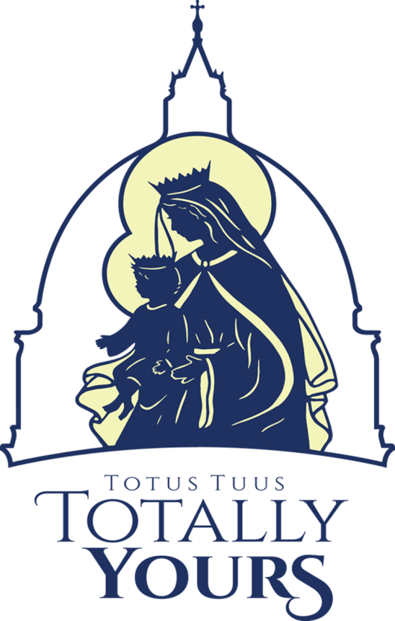

**Teen Program**

Students entering grades 7-12 (graduated seniors may also attend)

Sunday-Thursday 7:00-9:00pm

Join us for a week of engaging discussions, prayer opportunities, learning, games, and live changing witnesses of how to give yourself totally to God

Cost:

**Questions:**

Contact:

**Register by:**

Date:

**Grade School Program**

Students entering grades 1-6

Monday-Friday 9:00am-2:30pm

Join us for a fun, faith-filled day with games, skits, songs, sacraments, class, lunch, & recess

(Bring a sack Lunch)

Cost:

Faith, Friends, Fellowship, & Fun

Totus Tuus (a Latin phrase meaning “totally yours”) was the motto of Pope St. John Paul II. It signifies our desire to give ourselves entirely to Jesus Christ through the hands of our Blessed Mother Mary.

The mission of Totus Tuus is to inspire in young people a true longing for holiness. Seminarians and college students from the Archdiocese of Cincinnati carry this mission to every young person and participant of Totus Tuus.

The youth see that these young adults are joyful and on fire with the Catholic faith, which encourages them to strive for the same thing in their lives.

**Summer Youth Program**

**Dates:** Type your date in here

**Location:** Meeting Location