Taking Attendance for Your Live Course

- Log into Vocare with your account info at www.vocareonline.com.

- Click on the Instructor dropdown in the top menu and choose Attendance.

- On the Attendance screen, you will see all the courses that you have been assigned.

- Click on your course:
You will notice that each date of your sessions is separate. The names of participants are in each date.

- Click on the arrow next to the date to see the names. Mark attendance by clicking the box next to each person's name. You can select one at a time or, if everyone attended, click the box next to "Attended" to click all at once. Be sure to Update!

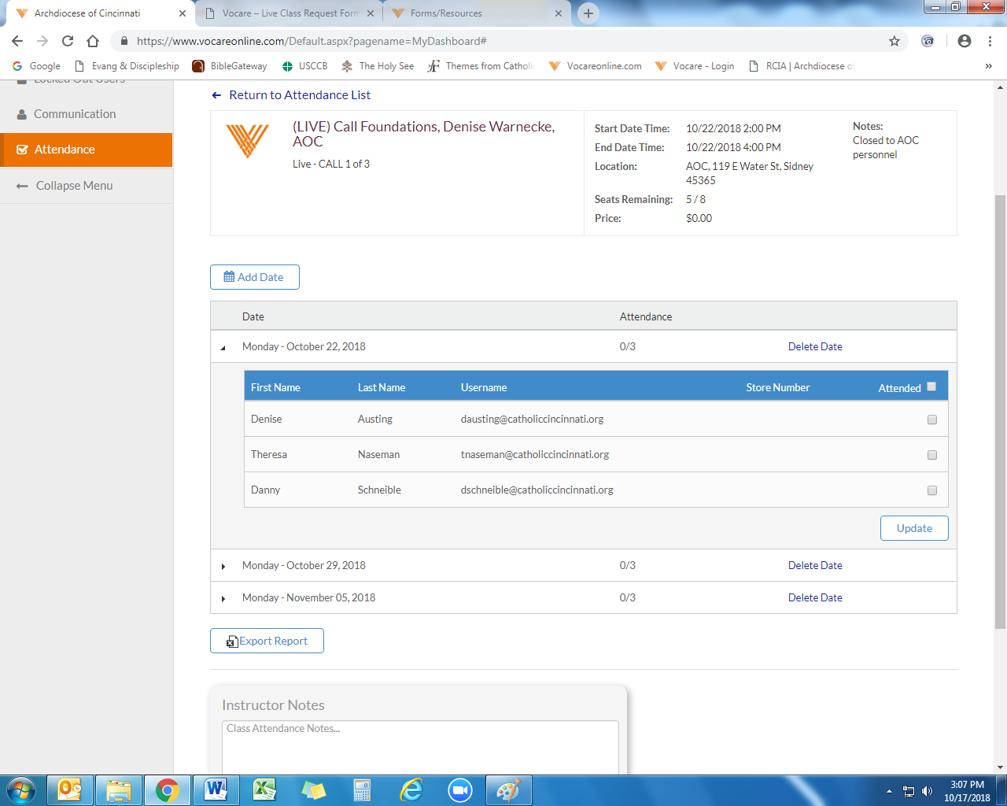

- Continue with the other dates when sessions are finished. In cases of inclement weather, you are able Delete Dates as needed and Add a different one.
Be sure to click the Update button to keep your changes!

!
- There is also a space to add your own notes/reminders about the course in the 'Instructor Notes' box at the bottom of the screen. Remember to “Save Notes.”
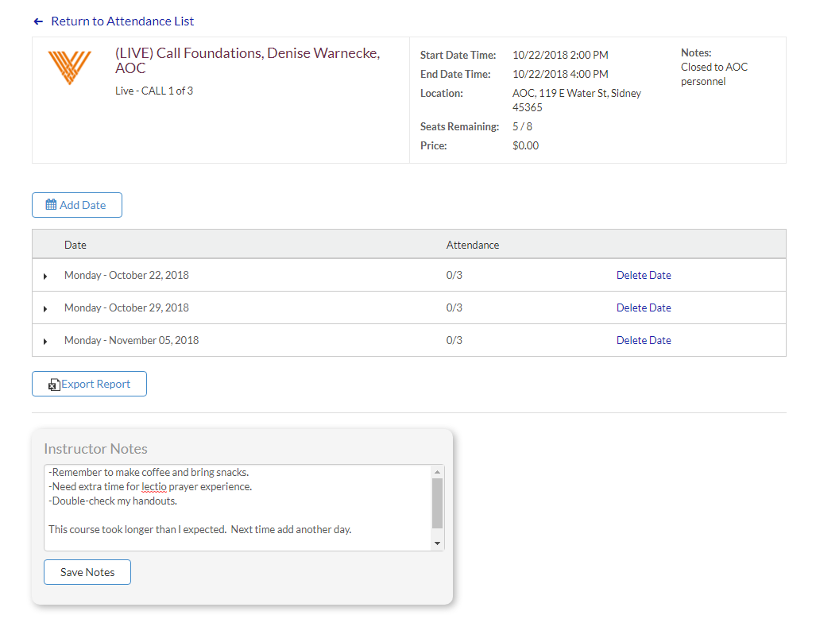

- Once the last session is finished, please contact VocareSupport@CatholicAOC.org so that credit can be issued.

- Please remember that NO SESSIONS should be held between June 15 and June 30. Credit may not be able to be issued if a course does not finish by June 15!

