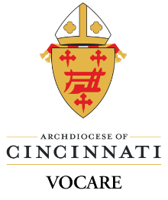
Payment of Multiple Catechists for Vocare Live Courses

Parish Name _____________________________________________________________________________

Parish Address _____________________________________________________________________________

Please circle the name of the Vocare course: (only choose ONE)

Call 1 Foundations
Call 2 Pillars of Faith
Call 3 Spirituality/Formation
Witness 1 Foundations
Witness 2 Created in God's Image
Witness 3 Liturgy and Sacraments
Proclaim 1 Foundations Proclaim 2 Living Faith Proclaim 3 Mass/Mary
Other Course:

First Name | Last Name | Email Address | Cost
 |  |  | $

A check for payment must accompany the form. Courses will be setup upon receipt of payment. Checks should be made payable to the:
Archdiocese of Cincinnati.

Please mail this form and payment in full to Archdiocese of Cincinnati
Vocare Administrator 119 E Water St

ALL LIVE COURSES MUST BE PRE-PAID. Sidney, OH 45365
* COURSES WILL NOT BE SET UP UNTIL
PAYMENT IS RECEIVED.

